Using Poisson to Model Predictors in Ideal Number of Children Using General Social Survey 2014: an Exploratory Study

Bill Yuanchen Liu

Generalized Linear Modeling

Dr. Shenyang Guo

December 13, 2018

**Introduction**

In October 2018 the Centers for Disease Control and Prevention (CDC) released a report on the national fertility rate trend. In it, the CDC highlighted that the United States is experiencing a decrease in total fertility rates, with significant drops in several key demographic groups that had shown consistent high fertility rates previously.1 For example, compared to other ethnic groups, Hispanic women showed the largest decline of 26%, 29%, and 30% in rural, suburban, and metro counties respectively. Birthrate also fell for women 15 to 19 years old, which is a 55% decrease since 2007 and a 70% decrease since 1991, when the most recent peak happened.1,2

This is not a surprising trend though, as many high-income countries are struggling with non-sustainable fertility rates.2 Industrialized countries tend to have better healthcare, more freedom for lifestyle choices, economic support, and birth control resources, among other factors that lower fertility rates. The normalization of higher education and professional careers for women also delay a decision to bring a child to life.3,4 However, women are key in maintaining a population. The concept of replacement fertility rate was devised to describe “a total fertility rate in which women would have only enough children to replace themselves and their partners.” This number is roughly 2.1 births per woman for high-income countries like the U.S. to keep a stable population.3 We are, however, sitting at around 1.95 for rural, 1.78 for suburban, and 1.71 for metro counties as of the latest reported data released by the CDC.1

Even though this is a normal phenomenon in high-income countries, a decreasing fertility rate does pose many problems. In fact, as a fundamental metric for a population, fertility rates have profound impacts. Fertility closely indicates economic health, as the proportion of youth in a population affects employment and worker force. This in turn relates to whether society can pay taxes and keep the government’s ability to provide key resources like law enforcement and healthcare.5 The emergence of different preferences for various age groups also affect consumption behaviours, which influences market, careers, and livelihood for all of us. Ethnic group fertility rates influence demographic proportions and even voting preferences for communities when elections are at an increasingly higher stake.6 Fertility is at the core of each individual’s motivation for life, as highlighted by MaRgolis et al., a negative to neutral to positive association was found between fertility and happiness as the age of respondent increases, regardless of sex, income, health status, welfare, partnership status, and other factors.7 The concept of fertility is therefore complex because of the multi-level, multi-faceted influence it exerts.

This study focuses on a core social aspect of fertility – the perspective of an individual on the ideal number of children as a proxy and precursor for the willingness to have children. Several demographic factors are tested, as literature suggest a differential effect for various groups.1 Whether the racial groups or the sexes differ in terms of perception of ideal number of children will be investigated.8 Respondent’s individual income level will act as a predictor for future family carrying capacity, a major decision factor in consideration of having a child.7 Education levels are included to study whether there is an ideological influence to the difference seen in fertility rates.

Furthermore, three other ecological variables are tested to look for correlation to the perception of ideal number of children. The individual’s perception on whether the government is spending too much in childcare will be a lead to test the institution’s influence in an individual’s psyche. A pre-marriage factor – the number of brothers and sisters growing up – is used to gain an idea on the individual’s view on the concept of family. This could also directly indicate a view on the proper family size. In comparison, a post-marriage factor is also included to gauge whether the perceived happiness of marriage had an effect on the ideal number of children. Happiness of marriage can also predict the status of the union, willingness to bear a child with the significant other, and the emotional confidence in future ability to raise a child.7

The research question is, therefore, if there is a statistically significant relationship between ideal number of children, sex, income, education, race, opinion of government’s role in childcare, number of siblings in family, and happiness of current marriage. The null hypothesis (H0) is there is no statistically significant model that can predict the ideal number of children based on the seven independent variables. The alternative hypothesis (Ha) is that there is a statistically significant model that can predict ideal number of children based on independent variables.

**Methods**

Data was retrieved from the 2014 General Social Surveys (GSS), conducted for the National Data Program for the Social Sciences at NORC, University of Chicago. Specific sampling methods, data processing, and data weighting procedures were described in its cumulative codebook released April 2016. Primary data collected in the surveys were collected from a national probability sample. The variables of interest were cleaned by removing entries with missing values, not applicable and no answer, leaving 375 data points in the working data file. One variable (happiness) was recoded in reversal due to the wording of the survey question to reflect the additive relationship of the other variables so it can be compared. The rest of the code were left as is, since all of the categorical variables are properly coded, and two measures in income and siblings had over 10 categories, treating it as a continuous variable.

The dependent variable, ideal number of children (ideal) is a non-normally distributed count variable with more than two levels. It is highly skewed. Because we are expecting an over-dispersion effect, both Poisson and multivariate negative binomial regression models are conducted to compare the two models. The structural model to predict the probability of for the numbers of the ideal number of children, according to the Poisson regression, is as follows:

Whereas the count variable y follows the Poisson distribution with parameter *μ* where *μ =E(y)=Var(y)*. Y stands for predicted counts of ideal number of children (y = 0, 1, 2, 3, 4, 5, 6 number of children); x1 for sex (sex2); x2 for respondent’s individual income ranging from $1000 to $150000 (income2); x3 for 5 dummy variables for highest degree held, ranging from high school to graduate level (degree2); x4 for 3 dummy variables for race of white, black, or others (race2); x5 for 3 dummy variables on the opinion on whether government is doing too little, about right, or too much in providing childcare (childcare); x6 for the number of brothers and sisters in the family (siblings); x7 for 3 dummy variables in perceived marriage happiness (happiness); ***β***for the vector of coefficients for each respective independent predictor showing the effect of the variable relative to the baseline outcome. For each categorical variable, the reference group is the baseline group with the lowest values.

STATA/SE 15 will be used for data analysis. A univariate Poisson model is generated to describe the dependent variable ideal. Combined with data from statistics generated using the summarize function, over dispersion effect will be judged. Afterwards, both Poisson model and negative binomial regression model (Negbin) are generated. An estimate table is created for comparison purposes. Using vce(robust) command, the appropriate model will be re-run. Incident rate ratio and percentage will be generated, as well as the Average Marginal Effects. Finally, a third model is constructed using an interaction term between siblings and happiness to test for interaction effects. The variables are run using a linear regression to calculate the VIF in order to determine the collinearity. Final results are presented in a graph.

**Results**

After data cleaning, 375 observations were used to conduct the analysis. The mean, standard deviation, and percentage distributions for the eight variables are presented in Table 1. In our sample population, 83% reported white, 9% black, and 9% others. 52% are male and 48% are female. The largest group of individuals chose 2 children as the ideal number of children (59%). This distribution is visibly skewed, and does not show normal distributed qualities (Graph 1). Other notable characteristic include the mean income for this sample population is 16.5, which indicates an individual income level between $30000 and $40000, with a standard deviation of approximately $5000. The mean sibling report is 3.4, with a large standard deviation of 2.4. None of the continuous variables followed a normal distribution. Siblings is positively skewed, while the other variables showing a bimodal or other relationship (Table 1).

According to STATA summarize statistics, the variance of ideal is smaller than the mean, the equi-dispersion assumption holds true. We cannot conclude that the variable has over-dispersion. Also, the skewness, kurtosis, and frequency distribution confirms our visual judgement that the variable is non-normally distributed and positively skewed (Table 2).

Univariate Poisson analysis on ideal variable reveals that the model does not fit to the data well. The model predicted probability for each count is different from the corresponding observed probability. The Poisson regression underestimated the probability of the count equal to two, and overestimated the probability at count equals to zero (Graph 2).

Running the preliminary Poisson and Negbin Model, the results show that the estimated over-dispersion parameter (alpha) is nearly zero. The likelihood ratio test of alpha = 0 shows a chi-square of 9.54 (df = 1), which is not statistically significant (p>.05). Given this evidence, we conclude that the Negbin model does not fit the data better than the Poisson regression (Table 3). STATA *estimate table* command show no difference in the estimated SEs between Poisson and Negbin. The results suggest that using the Poisson model in this study does not lead to a biased significance test (Table 4).

Running the robust Poisson model, a statistically significant Poisson regression model was constructed using ideal as the dependent variable, and sex2, income2, degree2, race2, childcare, siblings, and happiness as independent variables (Wald chi2(13) = 40.37, pseudo R2 = 0.0085, Prob > chi2 = 0.0001) (Table 5). Out of the categorical and continuous variables, only having a graduate degree (degree2 = 4), being black (race2 = 2), and siblings are statistically significant predictors of ideal number of children (p<.05; p=.001; p<.05 respectively). Interpreting the incidence-rate ratio using the variable siblings as an example, for every one additional sibling an individual have, the ideal number of children increases by a factor of 1.018, holding all other variables constant. Results show that other things being equal, having a graduate degree decreases the ideal number of children by 16.8%; being black increases the ideal number of children by 24.9%; for every one more sibling to have in the family, the ideal number of children increases by 1.8%. All other variables are not statistically significant. According to model predicted probabilities based on average marginal effects (AMEs), many conclusions can be drawn. For example, results show that the probability of reporting a zero ideal children for graduate degree is higher than those achieving high school by 0.024. This effect does not show statistical significance when comparing those with graduate degree and those with bachelor’s degree. For other interpretations please see Table 6.

Further testing the Poisson model with an interaction term between the pre-marriage proxy siblings and post-marriage proxy happiness shows no statistically significant interaction effect. In fact, including the interaction term decreased the model’s predictive ability (Wald chi2(15) = 41.22, pseudo R2 = 0.0085, Prob > chi2 = 0.0003) (Table 7). This is confirmed by a *correlation* command, where the two variables showed minimal correlation to each other. The results from the significant variables in the final model in Table 5 are graphed for representation even though there is no interaction effect (Graph 3). The main outcomes are summarized in Table 8.

In order to further diagnose the variables, a linear regression was run and VIF values are collected. Even though the variable happiness showed a dangerous VIF around 8, it may suggest collinearity that needed further testing.

**Discussion**

A statistically significant Poisson regression model was constructed using ideal as the dependent variable, and sex2, income2, degree2, race2, childcare, siblings, and happiness. Many of the variables are statistically insignificant individually, however, having a graduate education degree is negatively associated with the ideal number of children; being black is positively associated with the ideal number of children; and the number of siblings is positively correlated with the ideal number of children are separately statistically significant. No interaction effects were observed.

Through both generating visuals and looking for statistics, we can inference that the dependent variable is non-normally distributed but is not over-dispersed. Considering the count nature of the ideal variable, Poisson regression is justified over multivariate negative binomial regression.

These findings are curious because this study did not find the statistical significance illustrated in literature. This may be because of several limitations. Our sample size is reduced tenfold after eliminating no answers and missing values from the original dataset of approximately 6000 data points. This will restrict our ability to inference and the statistical power of the model.

Other limitations include failure to consider economic situation as a predictor of ideal number of children. Literature recognized that increasingly so, the burden of raising a child and supporting the child through life and education affect the choices of many families.3,5 It may be a more direct predictor than some of the variables in the model. However, this study is limited by the questions asked in GSS 2014. Another unaccounted factor in predicting the ideal number of children is faith and religiosity. Adsera highlighted in her 2006 paper that those identified as Conservative Protestants and Catholics report a higher ideal number of children.9 There seems to be a relationship between religiosity and its influences on deciding a life trajectory, influencing perception on the concept of family. These two factors can be studied in more extensive detail for future research to account for better context.

Despite various limitations to our model, this paper provides important preliminary research into possible indicators that associated with the willingness for an individual to have a child. This will be a key step in constructing an ecological framework for birth incentive programs or childcare support programs. Based on significant statistical relationships, a program targeting evidence-associated factors will likely to be more effective. This will be increasingly important as the United States deal with the decreasing fertility rates. In the near future, policy makers will have to think of effective, non-coercive ways of promoting birth.10 Alternatively, the falling fertility rates and its potential adverse impacts provide a sound supporting argument for creating better immigration policies.

**Conclusion**

In short, this study found a statistically significant Poisson regression model to predict the ideal number of children from sex, income, education, race, opinion on government childcare, number of siblings, and happiness of marriage. Only having a graduate degree, being black, and the number of siblings are statistically significant predictors of the ideal number of children. This may be because of our natural limitation in the survey design and sample size as well as unaccounted factors in the theoretical framework or logic model to the topic. The considerations highlighted above warrant further research into this topic area, considering its implications and importance. Despite these considerations, this paper offers insights on factors that can be considered in addressing the current failing fertility rates in the United States.

**Works Cited**

1. Centers for Disease Control and Prevention. *Trends in Fertility and Mother’s Age at First Birth Among Rural and Metropolitan Counties: United States, 2007–2017*.; 2018. https://www.cdc.gov/nchs/products/databriefs/db323.htm. Accessed December 13, 2018.

2. Chappell B. U.S. Births Dip To 30-Year Low; Fertility Rate Sinks Further Below Replacement Level. *NPR.org*. https://www.npr.org/sections/thetwo-way/2018/05/17/611898421/u-s-births-falls-to-30-year-low-sending-fertility-rate-to-a-record-low. Published May 17, 2018. Accessed December 13, 2018.

3. Nargund G. Declining birth rate in Developed Countries: A radical policy re-think is required. *Facts Views Vis Obgyn*. 2009;1(3):191-193.

4. Rindfuss RR, Bumpass L, St. John C. Education and Fertility: Implications for the Roles Women Occupy. *American Sociological Review*. 1980;45(3):431-447. doi:10.2307/2095176

5. Cha AE. As U.S. fertility rates collapse, finger-pointing and blame follow. *Washington Post*. https://www.washingtonpost.com/health/2018/10/19/us-fertility-rates-collapse-finger-pointing-blame-follow/. Published October 19, 2018. Accessed December 13, 2018.

6. Sweeney MM, Raley RK. Race, Ethnicity, and the Changing Context of Childbearing in the United States. *Annu Rev Sociol*. 2014;40:539-558. doi:10.1146/annurev-soc-071913-043342

7. MaRgolis R, MyRskylä M. A Global Perspective on Happiness and Fertility. *Popul Dev Rev*. 2011;37(1):29-56.

8. Golmakani N, Fazeli E, Taghipour A, Shakeri MT. Relationship between gender role attitude and fertility rate in women referring to health centers in Mashhad in 2013. *Iran J Nurs Midwifery Res*. 2015;20(2):269-274.

9. Adsera A. Religion and Changes in Family-Size Norms in Developed Countries. *Review of Religious Research*. 2006;47(3):271-286.

10. Searchinger T, Hanson C, Waite R, Lipinski B, Leeson G, Harper S. Achieving Replacement Level Fertility | World Resources Institute. World Resources Institute. https://www.wri.org/publication/achieving-replacement-level-fertility. Published August 2013. Accessed December 13, 2018.

**Appendix**

**Table 1: Descriptive statistics for independent and dependent variables.**

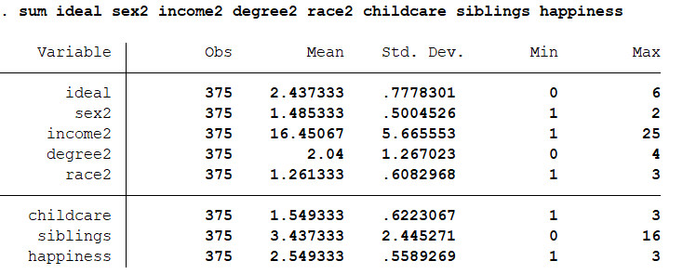

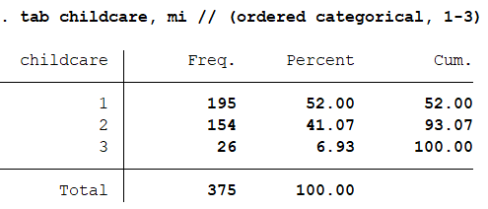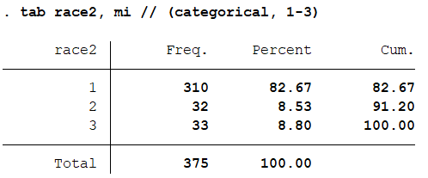

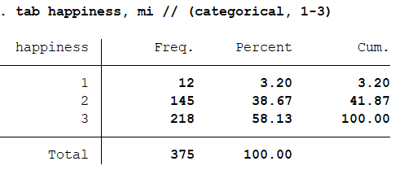

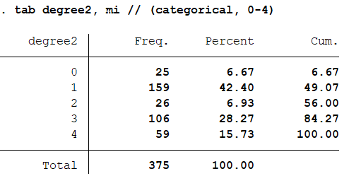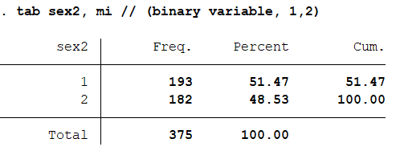

**Table 2: Description of over dispersion statistics.**

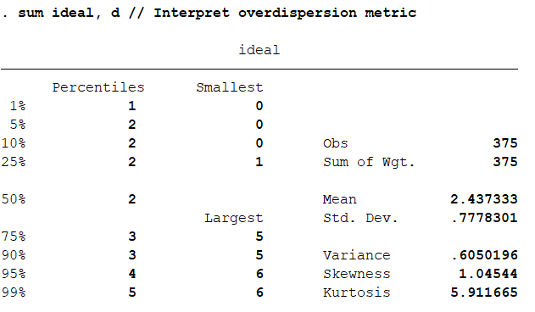

**Table 3: Preliminary model building using Poisson and Negbin regression.**

. poisson ideal i.sex2 income2 i.degree2 i.race2 i.childcare siblings i.happiness

Iteration 0: log likelihood = -556.57711

Iteration 1: log likelihood = -556.57711

Poisson regression Number of obs = 375

LR chi2(13) = 9.54

Prob > chi2 = 0.7311

Log likelihood = -556.57711 Pseudo R2 = 0.0085

------------------------------------------------------------------------------

ideal | Coef. Std. Err. z P>|z| [95% Conf. Interval]

-------------+----------------------------------------------------------------

2.sex2 | -.0170589 .0737163 -0.23 0.817 -.1615402 .1274223

income2 | .0043753 .0070025 0.62 0.532 -.0093494 .0181

|

degree2 |

1 | -.0759973 .1376031 -0.55 0.581 -.3456943 .1936997

2 | -.1017844 .1863106 -0.55 0.585 -.4669464 .2633776

3 | -.1121175 .1504275 -0.75 0.456 -.40695 .1827151

4 | -.1833302 .1658312 -1.11 0.269 -.5083535 .141693

|

race2 |

2 | .2220558 .1113997 1.99 0.046 .0037165 .4403951

3 | .0299593 .1197781 0.25 0.802 -.2048014 .26472

|

childcare |

2 | .0191954 .0723917 0.27 0.791 -.1226898 .1610805

3 | .0081909 .1337762 0.06 0.951 -.2540056 .2703874

|

siblings | .0183196 .0144983 1.26 0.206 -.0100966 .0467358

|

happiness |

2 | .0581803 .2012163 0.29 0.772 -.3361964 .452557

3 | .0655894 .1991634 0.33 0.742 -.3247636 .4559424

|

_cons | .7683537 .2557202 3.00 0.003 .2671514 1.269556

------------------------------------------------------------------------------

. nbreg ideal i.sex2 income2 i.degree2 i.race2 i.childcare siblings i.happiness

Fitting Poisson model:

Iteration 0: log likelihood = -556.57711

Iteration 1: log likelihood = -556.57711

Fitting constant-only model:

Iteration 0: log likelihood = -777.23636

Iteration 1: log likelihood = -561.34666

Iteration 2: log likelihood = -561.34666

Fitting full model:

Iteration 0: log likelihood = -556.58872

Iteration 1: log likelihood = -556.57711

Iteration 2: log likelihood = -556.57711

Negative binomial regression Number of obs = 375

LR chi2(13) = 9.54

Dispersion = mean Prob > chi2 = 0.7311

Log likelihood = -556.57711 Pseudo R2 = 0.0085

------------------------------------------------------------------------------

ideal | Coef. Std. Err. z P>|z| [95% Conf. Interval]

-------------+----------------------------------------------------------------

2.sex2 | -.0170589 .0737163 -0.23 0.817 -.1615402 .1274223

income2 | .0043753 .0070025 0.62 0.532 -.0093494 .0181

|

degree2 |

1 | -.0759973 .1376031 -0.55 0.581 -.3456943 .1936997

2 | -.1017844 .1863106 -0.55 0.585 -.4669464 .2633776

3 | -.1121175 .1504275 -0.75 0.456 -.40695 .1827151

4 | -.1833302 .1658312 -1.11 0.269 -.5083535 .141693

|

race2 |

2 | .2220557 .1113997 1.99 0.046 .0037164 .4403951

3 | .0299593 .1197781 0.25 0.802 -.2048014 .26472

|

childcare |

2 | .0191954 .0723917 0.27 0.791 -.1226898 .1610805

3 | .0081909 .1337762 0.06 0.951 -.2540056 .2703874

|

siblings | .0183196 .0144983 1.26 0.206 -.0100966 .0467358

|

happiness |

2 | .0581803 .2012163 0.29 0.772 -.3361964 .452557

3 | .0655894 .1991634 0.33 0.742 -.3247636 .4559424

|

_cons | .7683537 .2557202 3.00 0.003 .2671514 1.269556

-------------+----------------------------------------------------------------

/lnalpha | -70.59353 . . .

-------------+----------------------------------------------------------------

alpha | 2.20e-31 . . .

------------------------------------------------------------------------------

LR test of alpha=0: chibar2(01) = 0.00 Prob >= chibar2 = 1.000

**Table 4: Estimates table for Poisson and Negbin regression.**

. estimate table prm negbin, b(%9.3f) se p(%9.3f) eform

--------------------------------------

Variable | prm negbin

-------------+------------------------

ideal |

sex2 |

2 | 0.983 0.983

| 0.072 0.072

| 0.817 0.817

|

income2 | 1.004 1.004

| 0.007 0.007

| 0.532 0.532

|

degree2 |

1 | 0.927 0.927

| 0.128 0.128

| 0.581 0.581

2 | 0.903 0.903

| 0.168 0.168

| 0.585 0.585

3 | 0.894 0.894

| 0.134 0.134

| 0.456 0.456

4 | 0.832 0.832

| 0.138 0.138

| 0.269 0.269

|

race2 |

2 | 1.249 1.249

| 0.139 0.139

| 0.046 0.046

3 | 1.030 1.030

| 0.123 0.123

| 0.802 0.802

|

childcare |

2 | 1.019 1.019

| 0.074 0.074

| 0.791 0.791

3 | 1.008 1.008

| 0.135 0.135

| 0.951 0.951

|

siblings | 1.018 1.018

| 0.015 0.015

| 0.206 0.206

|

happiness |

2 | 1.060 1.060

| 0.213 0.213

| 0.772 0.772

3 | 1.068 1.068

| 0.213 0.213

| 0.742 0.742

|

_cons | 2.156 2.156

| 0.551 0.551

| 0.003 0.003

-------------+------------------------

/lnalpha | 0.000

| 0.000

| .

--------------------------------------

legend: b/se/p

**Table 5: A robust Poisson model with IRR and Percentage outputs**

. poisson ideal i.sex2 income2 i.degree2 i.race2 i.childcare siblings i.happiness, vce(robust)

Iteration 0: log pseudolikelihood = -556.57711

Iteration 1: log pseudolikelihood = -556.57711

Poisson regression Number of obs = 375

Wald chi2(13) = 40.37

Prob > chi2 = 0.0001

Log pseudolikelihood = -556.57711 Pseudo R2 = 0.0085

------------------------------------------------------------------------------

| Robust

ideal | Coef. Std. Err. z P>|z| [95% Conf. Interval]

-------------+----------------------------------------------------------------

2.sex2 | -.0170589 .0334789 -0.51 0.610 -.0826764 .0485585

income2 | .0043753 .0033454 1.31 0.191 -.0021817 .0109323

|

degree2 |

1 | -.0759973 .0728844 -1.04 0.297 -.2188482 .0668536

2 | -.1017844 .0893343 -1.14 0.255 -.2768765 .0733077

3 | -.1121175 .0783056 -1.43 0.152 -.2655935 .0413586

4 | -.1833302 .0805038 -2.28 0.023 -.3411147 -.0255457

|

race2 |

2 | .2220558 .0662615 3.35 0.001 .0921856 .351926

3 | .0299593 .057364 0.52 0.601 -.0824721 .1423908

|

childcare |

2 | .0191954 .0337897 0.57 0.570 -.0470313 .085422

3 | .0081909 .0586341 0.14 0.889 -.1067298 .1231117

|

siblings | .0183196 .0075782 2.42 0.016 .0034667 .0331725

|

happiness |

2 | .0581803 .0986325 0.59 0.555 -.1351358 .2514963

3 | .0655894 .0985994 0.67 0.506 -.1276618 .2588406

|

_cons | .7683537 .1429429 5.38 0.000 .4881906 1.048517

------------------------------------------------------------------------------

.

. // IRRS and percentage

. listcoef, help

poisson (N=375): Factor change in expected count

Observed SD: 0.7778

------------------------------------------------------------------------

| b z P>|z| e^b e^bStdX SDofX

-------------+----------------------------------------------------------

2.sex2 | -0.0171 -0.510 0.610 0.983 0.991 0.500

income2 | 0.0044 1.308 0.191 1.004 1.025 5.666

|

degree2 |

1 | -0.0760 -1.043 0.297 0.927 0.963 0.495

2 | -0.1018 -1.139 0.255 0.903 0.974 0.254

3 | -0.1121 -1.432 0.152 0.894 0.951 0.451

4 | -0.1833 -2.277 0.023 0.832 0.935 0.365

|

race2 |

2 | 0.2221 3.351 0.001 1.249 1.064 0.280

3 | 0.0300 0.522 0.601 1.030 1.009 0.284

|

childcare |

2 | 0.0192 0.568 0.570 1.019 1.010 0.493

3 | 0.0082 0.140 0.889 1.008 1.002 0.254

|

siblings | 0.0183 2.417 0.016 1.018 1.046 2.445

|

happiness |

2 | 0.0582 0.590 0.555 1.060 1.029 0.488

3 | 0.0656 0.665 0.506 1.068 1.033 0.494

|

constant | 0.7684 5.375 0.000 . . .

------------------------------------------------------------------------

b = raw coefficient

z = z-score for test of b=0

P>|z| = p-value for z-test

e^b = exp(b) = factor change in expected count for unit increase in X

e^bStdX = exp(b*SD of X) = change in expected count for SD increase in X

SDofX = standard deviation of X

. listcoef, percent help

poisson (N=375): Percentage change in expected count

Observed SD: 0.7778

------------------------------------------------------------------------

| b z P>|z| % %StdX SDofX

-------------+----------------------------------------------------------

2.sex2 | -0.0171 -0.510 0.610 -1.7 -0.9 0.500

income2 | 0.0044 1.308 0.191 0.4 2.5 5.666

|

degree2 |

1 | -0.0760 -1.043 0.297 -7.3 -3.7 0.495

2 | -0.1018 -1.139 0.255 -9.7 -2.6 0.254

3 | -0.1121 -1.432 0.152 -10.6 -4.9 0.451

4 | -0.1833 -2.277 0.023 -16.8 -6.5 0.365

|

race2 |

2 | 0.2221 3.351 0.001 24.9 6.4 0.280

3 | 0.0300 0.522 0.601 3.0 0.9 0.284

|

childcare |

2 | 0.0192 0.568 0.570 1.9 1.0 0.493

3 | 0.0082 0.140 0.889 0.8 0.2 0.254

|

siblings | 0.0183 2.417 0.016 1.8 4.6 2.445

|

happiness |

2 | 0.0582 0.590 0.555 6.0 2.9 0.488

3 | 0.0656 0.665 0.506 6.8 3.3 0.494

|

constant | 0.7684 5.375 0.000 . . .

------------------------------------------------------------------------

b = raw coefficient

z = z-score for test of b=0

P>|z| = p-value for z-test

% = percent change in expected count for unit increase in X

%StdX = percent change in expected count for SD increase in X

SDofX = standard deviation of X

**Table 6: Predicted Probabilities based on the Average Marginal Effects (AMEs).**

. mchange, pr(0/6)

poisson: Changes in Pr(y) | Number of obs = 375

Expression: Pr(ideal), predict(pr())

| 0 1 2 3 4 5 6

-------------+-----------------------------------------------------------------------------

sex2 |

2 vs 1 | 0.004 0.005 0.002 -0.002 -0.003 -0.003 -0.002

p-value | 0.611 0.610 0.608 0.613 0.611 0.610 0.609

income2 |

+1 | -0.001 -0.001 -0.000 0.000 0.001 0.001 0.000

p-value | 0.191 0.190 0.194 0.189 0.189 0.191 0.193

+SD | -0.005 -0.007 -0.003 0.003 0.005 0.004 0.002

p-value | 0.184 0.191 0.215 0.170 0.189 0.197 0.205

Marginal | -0.001 -0.001 -0.000 0.001 0.001 0.001 0.000

p-value | 0.192 0.190 0.189 0.193 0.189 0.189 0.190

degree2 |

1 vs 0 | 0.015 0.023 0.011 -0.007 -0.015 -0.013 -0.008

p-value | 0.275 0.298 0.351 0.215 0.290 0.315 0.333

2 vs 0 | 0.020 0.031 0.014 -0.009 -0.020 -0.017 -0.011

p-value | 0.246 0.255 0.287 0.233 0.251 0.263 0.275

3 vs 0 | 0.023 0.034 0.015 -0.011 -0.022 -0.019 -0.011

p-value | 0.130 0.153 0.217 0.083 0.146 0.172 0.194

4 vs 0 | 0.039 0.055 0.021 -0.020 -0.036 -0.029 -0.017

p-value | 0.014 0.024 0.079 0.005 0.020 0.035 0.051

2 vs 1 | 0.005 0.008 0.003 -0.003 -0.005 -0.004 -0.002

p-value | 0.665 0.661 0.650 0.671 0.662 0.658 0.655

3 vs 1 | 0.008 0.011 0.004 -0.004 -0.007 -0.006 -0.003

p-value | 0.368 0.366 0.365 0.369 0.366 0.365 0.366

4 vs 1 | 0.024 0.032 0.010 -0.014 -0.021 -0.016 -0.009

p-value | 0.017 0.015 0.014 0.019 0.015 0.014 0.014

3 vs 2 | 0.002 0.003 0.001 -0.001 -0.002 -0.002 -0.001

p-value | 0.863 0.864 0.866 0.862 0.864 0.864 0.865

4 vs 2 | 0.019 0.024 0.007 -0.011 -0.016 -0.012 -0.007

p-value | 0.173 0.185 0.247 0.160 0.183 0.197 0.210

4 vs 3 | 0.016 0.021 0.006 -0.010 -0.014 -0.010 -0.006

p-value | 0.090 0.087 0.089 0.093 0.087 0.086 0.086

race2 |

2 vs 1 | -0.042 -0.067 -0.035 0.016 0.042 0.039 0.026

p-value | 0.000 0.001 0.011 0.000 0.000 0.002 0.007

3 vs 1 | -0.006 -0.009 -0.003 0.004 0.006 0.005 0.003

p-value | 0.595 0.603 0.625 0.584 0.601 0.609 0.614

3 vs 2 | 0.035 0.058 0.032 -0.012 -0.036 -0.035 -0.023

p-value | 0.020 0.021 0.034 0.052 0.018 0.023 0.031

childcare |

2 vs 1 | -0.004 -0.006 -0.002 0.002 0.004 0.003 0.002

p-value | 0.569 0.570 0.575 0.566 0.569 0.571 0.573

3 vs 1 | -0.002 -0.002 -0.001 0.001 0.002 0.001 0.001

p-value | 0.888 0.889 0.891 0.888 0.889 0.889 0.890

3 vs 2 | 0.002 0.003 0.001 -0.001 -0.002 -0.002 -0.001

p-value | 0.858 0.857 0.855 0.859 0.857 0.856 0.856

siblings |

+1 | -0.004 -0.006 -0.002 0.002 0.004 0.003 0.002

p-value | 0.014 0.015 0.023 0.011 0.014 0.017 0.020

+SD | -0.009 -0.014 -0.005 0.005 0.009 0.007 0.004

p-value | 0.012 0.015 0.030 0.007 0.014 0.019 0.024

Marginal | -0.004 -0.006 -0.002 0.002 0.004 0.003 0.002

p-value | 0.016 0.015 0.018 0.015 0.015 0.016 0.017

happiness |

2 vs 1 | -0.013 -0.017 -0.005 0.007 0.011 0.009 0.005

p-value | 0.568 0.551 0.484 0.583 0.553 0.538 0.525

3 vs 1 | -0.015 -0.020 -0.006 0.008 0.013 0.010 0.006

p-value | 0.522 0.500 0.420 0.541 0.503 0.484 0.469

3 vs 2 | -0.002 -0.002 -0.001 0.001 0.001 0.001 0.001

p-value | 0.818 0.818 0.818 0.818 0.818 0.818 0.818

Average predictions

| 0 1 2 3 4 5 6

-------------+-----------------------------------------------------------------------------

Pr(y|base) | 0.090 0.214 0.257 0.208 0.127 0.063 0.026

**Table 7: Testing for interaction using the Poisson regression.**

. poisson ideal i.sex2 income2 i.degree2 i.race2 i.childcare siblings i.happiness c.siblings##i.happiness, vce(robust)

note: siblings omitted because of collinearity

Iteration 0: log pseudolikelihood = -556.56415

Iteration 1: log pseudolikelihood = -556.56414

Poisson regression Number of obs = 375

Wald chi2(15) = 41.22

Prob > chi2 = 0.0003

Log pseudolikelihood = -556.56414 Pseudo R2 = 0.0085

--------------------------------------------------------------------------------------

| Robust

ideal | Coef. Std. Err. z P>|z| [95% Conf. Interval]

---------------------+----------------------------------------------------------------

2.sex2 | -.0162521 .0330315 -0.49 0.623 -.0809926 .0484884

income2 | .0044828 .0032476 1.38 0.167 -.0018825 .010848

|

degree2 |

1 | -.0758893 .0721215 -1.05 0.293 -.2172449 .0654662

2 | -.1001786 .0896709 -1.12 0.264 -.2759303 .0755731

3 | -.1109895 .0787757 -1.41 0.159 -.265387 .043408

4 | -.1805915 .0814006 -2.22 0.027 -.3401338 -.0210493

|

race2 |

2 | .2232495 .0669075 3.34 0.001 .0921133 .3543858

3 | .0297018 .0573929 0.52 0.605 -.0827862 .1421898

|

childcare |

2 | .0187416 .0338401 0.55 0.580 -.0475838 .0850671

3 | .0071049 .0589054 0.12 0.904 -.1083477 .1225574

|

siblings | .008515 .0462808 0.18 0.854 -.0821938 .0992238

|

happiness |

2 | .0054868 .2715309 0.02 0.984 -.526704 .5376776

3 | .015363 .2713923 0.06 0.955 -.5165561 .5472822

|

siblings | 0 (omitted)

|

happiness#c.siblings |

2 | .0107968 .0473582 0.23 0.820 -.0820235 .1036172

3 | .0101038 .0472094 0.21 0.831 -.082425 .1026326

|

_cons | .8146102 .2824827 2.88 0.004 .2609542 1.368266

**Table 8: Main Outcomes of the Study.**

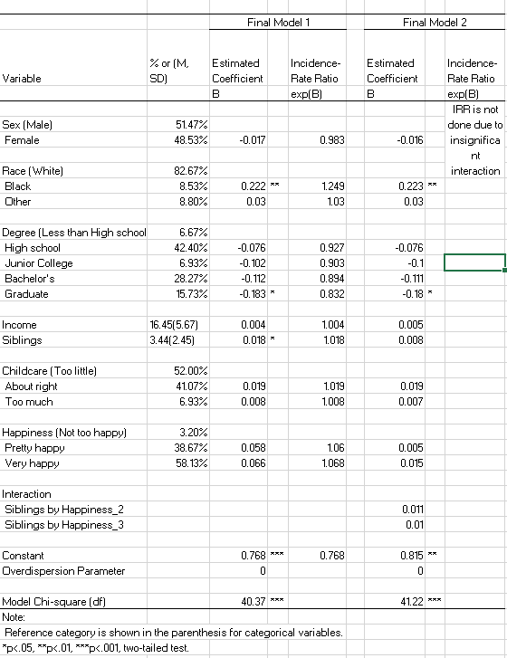

**Graph 1: Histogram on dependent variable, ideal.**

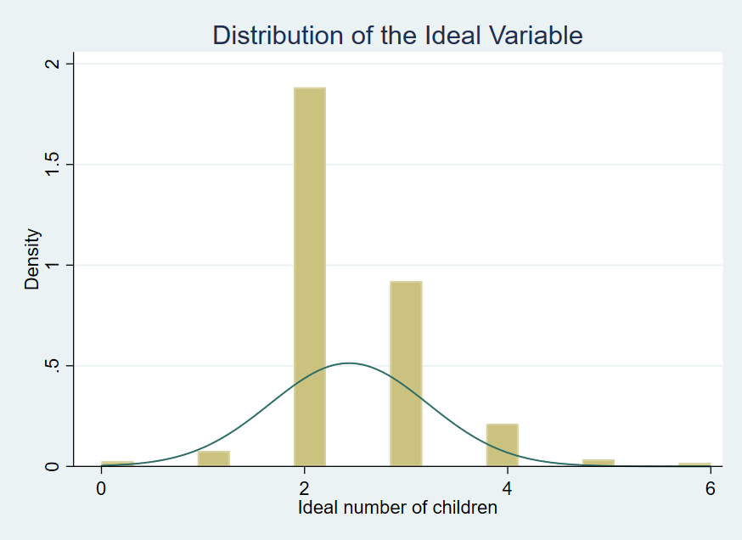

**Graph 2: Univariate analysis for dependent variable, ideal.**

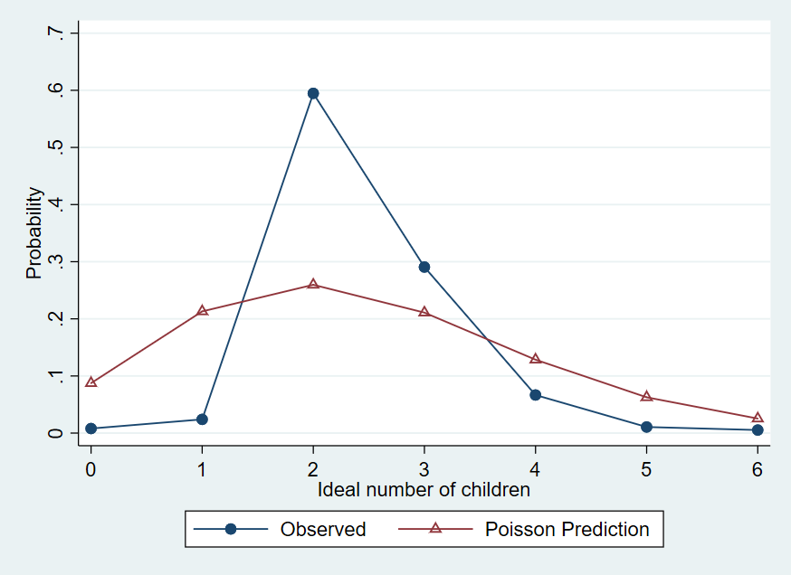

**Graph 3: Significant demographic outcomes: association of education level and race on the ideal number of children.**

